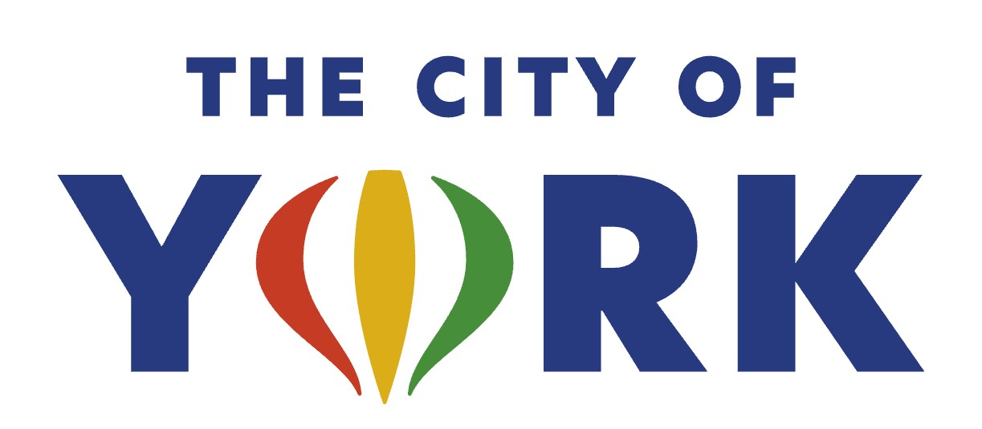

**Library Director – Kilgore Memorial Library**

The City of York is accepting applications for the position of Library Director for the Kilgore Memorial Library. The Director of the Library will plan, direct organize and manage all departmental policies; set goals and objective that enhance the mission and vision of the city; provide leadership, direction and administrative oversight for the development or maintenance of all operations of the library; provide community engagement and public involvement with elected officials, other policy makers and citizens; and serve as a member of the City of York Senior Leadership Team.

The successful applicant should have general knowledge of federal and state statutes related to public library governance; strong leadership skills, good organizational skills, excellent oral and written communication skills, and proficient with Microsoft Office suite products. Bilingual communication skills, preferred.

Education: Master’s Degree in Library Science from an American Library Association accredited institution and a current Certification by the Nebraska Library Commission.

Experience: Five years of progressively responsible professional library experience, including three years management or administration experience in a leadership role. Public library experience, preferred.

The City of York provides a competitive hourly wage based upon experience and qualifications, as well as an excellent benefit package. Applicant must be 18 years of age and authorized to work in the United States. Apply online at [www.cityofyork.ne.gov](http://www.cityofyork.ne.gov) or email your application and resume to [dpfeifer@cityofyork.ne.gov](mailto:dpfeifer@cityofyork.ne.gov%20)  or mail to Denise Pfeifer, HR Director, 100 E. 4th Street, York NE 68467.

**Applications will be accepted until the position is filled; first review will be October 29, 2025.**

**City of York is an Equal Opportunity Employer**